**Recursive Relationships**

As you just learned, a *recursive relationship* is one in which a relationship can exist between occurrences of the same entity set. (Naturally, such a condition is found within a unary relationship.)

**Many-to-many Unary relationship example**

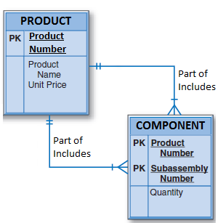

Unary relationships are common in manufacturing industries. For example, Figure 4.19 illustrates that a rotor assembly (C-130) is composed of many parts, but each part is used to create only one rotor assembly. Figure 4.19 indicates that a rotor assembly is composed of four 2.5-cm washers, two cotter pins, one 2.5-cm steel shank, four 10.25-cm rotor blades, and two 2.5-cm hex nuts. The relationship implemented in Figure 4.19 thus enables you to track each part within each rotor assembly.

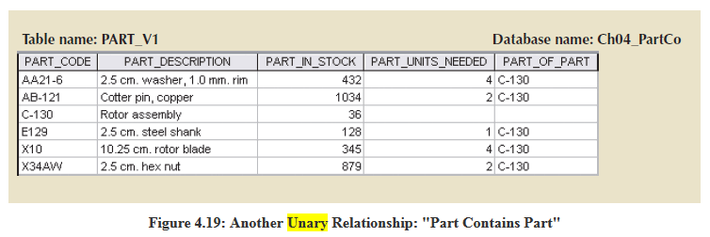

If a part can be used to assemble several different kinds of other parts and is itself composed of many parts, two tables are required to implement the "PART contains PART" relationship. Figure 4.20 illustrates such an environment. Parts tracking is increasingly important as managers become more aware of the legal ramifications of producing more complex output. In many industries, especially those involving aviation, full parts tracking is required by law.

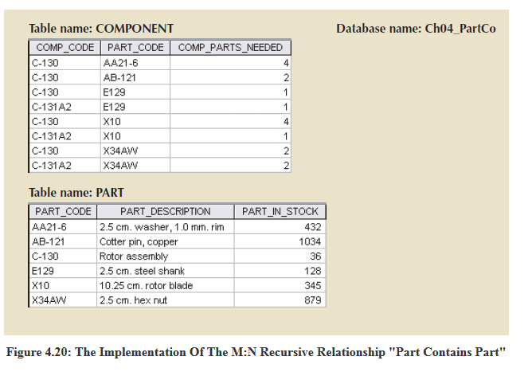

**Another example**

At Legacy Research Institute, a physician is assigned as a mentor to zero to many other physicians. Each physician is mentored by one to many other physicians.

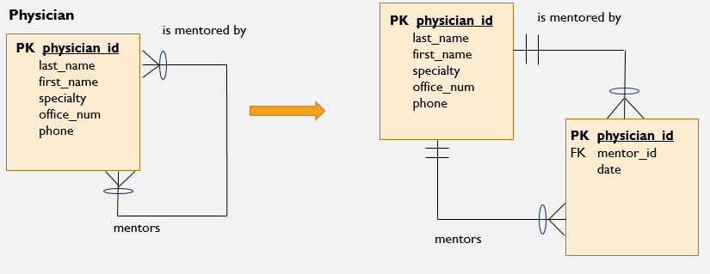

In the example above, mentor_id is actually the physician_id of the physician’s mentor. Because a physician can have many mentors, we cannot store this information in just one table (please see table below). This is similar to a linking table or associative entity you would see for a binary many-to-many relationship.

Note that in the table below, we will have a duplicate primary key if we try to assign more than one mentor to a particular physician.

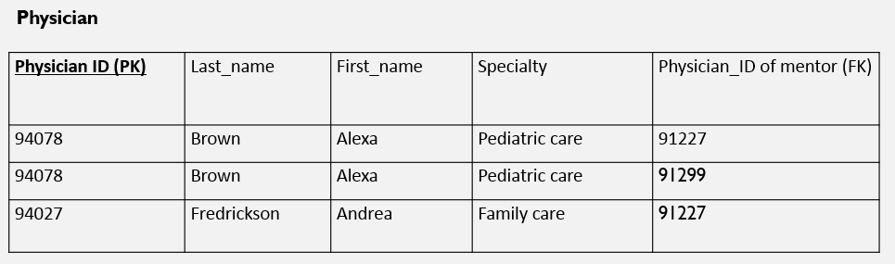

Adding the Mentor Assignment table allows us to assign multiple mentors to one physician:

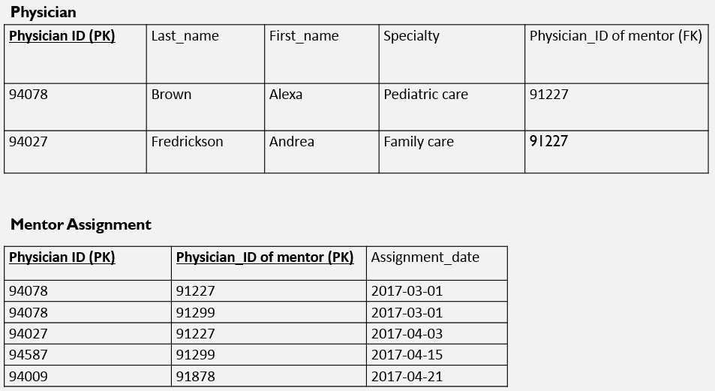

Unary relationships are also discussed near the end of this video - Entity Relationship Modeling[recording](https://wgu.hosted.panopto.com/Panopto/Pages/Viewer.aspx?id=bae03e4f-4a5f-44ca-ae59-ca2bf66ce2f1)